EXPT NO:8 | FORECASTING AND PREDICTIVE ANALYTICS USING TABLEAU  AND POWER BI
DATE: 14.08.2026

PRE-LAB QUESTIONS
- What is forecasting in the context of Business Intelligence (BI)?
Forecasting in BI is the practice of using historical data, statistical algorithms, and machine learning techniques to project future business metrics such as revenue, sales, and demand trends. It helps organizations transition from reactive reporting to proactive decision-making. By identifying underlying patterns like seasonality and growth, BI forecasting assists teams in setting realistic financial targets and managing risks effectively.
- Explain the difference between predictive analytics and descriptive analytics.
Descriptive analytics focuses on summarizing historical data to explain what has already happened in a business (e.g., past quarter sales reports). In contrast, predictive analytics analyzes historical and current patterns to forecast what is likely to happen in the future (e.g., next month's sales projections). While descriptive analytics relies on aggregations and basic visualizations, predictive analytics uses statistical modeling, machine learning, and trend analysis.
- Name two common forecasting methods used in Tableau and Power BI.
Two widely used methods are Exponential Smoothing and Linear Regression. Exponential Smoothing models time series data by giving exponentially decreasing weights to older observations, making it ideal for capturing trend and seasonality patterns. Linear Regression establishes a straight mathematical trend line over time to predict future numeric values based on historical momentum. Both techniques are natively integrated into Tableau's analytics pane and Power BI's line chart analytics tab.

- Why is data granularity important for accurate forecasting?
Data granularity determines the level of detail (e.g., daily, weekly, monthly) at which time series analysis is performed. Choosing the right granularity ensures the model captures true underlying patterns, such as weekly consumer buying spikes, without adding excessive high-frequency noise. If data is aggregated too broadly (e.g., yearly), critical seasonal nuances are lost; if too granular (e.g., hourly), missing values and random variance can degrade forecast precision

- Name two challenges in forecasting using multiple data sources.
One primary challenge is data alignment and inconsistency, where different datasets use conflicting date formats, time zones, or aggregation intervals (e.g., daily sales vs. monthly promotion windows). Another challenge is handling schema mismatch and missing foreign keys, which can lead to incomplete joins or duplicate records during integration. These discrepancies skew time-series continuity, leading to unreliable predictive outputs and distorted error margins

IN-LAB EXERCISE:
OBJECTIVE:
To perform time series forecasting and predictive analytics on historical sales data using Tableau and Power BI, and visualize future trends for informed decision-making. PROCEDURE:
- Data Collection:
  - Import historical sales data from multiple sources:
    - Dataset 1: Sales Data (CSV) → Order ID, Order Date, Region, Sales Amount
    - Dataset 2: Promotions Data (Excel) → Promotion ID, Region, Promotion Start Date, Promotion End Date, Discount
- Data Preparation and Transformation:
  - Clean data: standardize date formats, remove duplicates, handle missing values.
  - Aggregate sales data at the required granularity (daily, weekly, or monthly).
  - Ensure numeric fields (Sales, Discount) are correct.
- Data Integration and Modeling:
  - Tableau: Connect datasets and relate them using the Region field.
  - Power BI: Create relationships in the Model view; define cardinality where necessary.
- Forecasting and Predictive Analytics:
  - Tableau:
    - Use the Forecast feature on Sales over time. o Apply trend models like Exponential Smoothing and visualize prediction intervals.
  - Power BI:
    - Use built-in forecasting in line charts. o Optionally, create a DAX measure for predicted sales using moving averages or linear regression.
- Create Calculated Fields:
  - Forecasted Sales = Predicted value from the model
  - Sales Growth % = ((Forecasted Sales – Actual Sales) / Actual Sales) * 100
- Design a Comprehensive Dashboard:
  - Line chart showing actual vs. forecasted sales over time.
  - KPI cards: Total Forecasted Sales, Expected Growth %.
  - Use combo charts to show sales trends along with promotion periods.
  - Highlight regions with expected growth above or below target thresholds.
- Validate Forecast Accuracy:
  - Compare forecasts against actual historical sales (back-testing).
  - Adjust forecasting parameters if necessary (e.g., seasonality length, smoothing factor).
- Publishing and Sharing:
  - Tableau: Publish workbook to Tableau Public or Tableau Server.
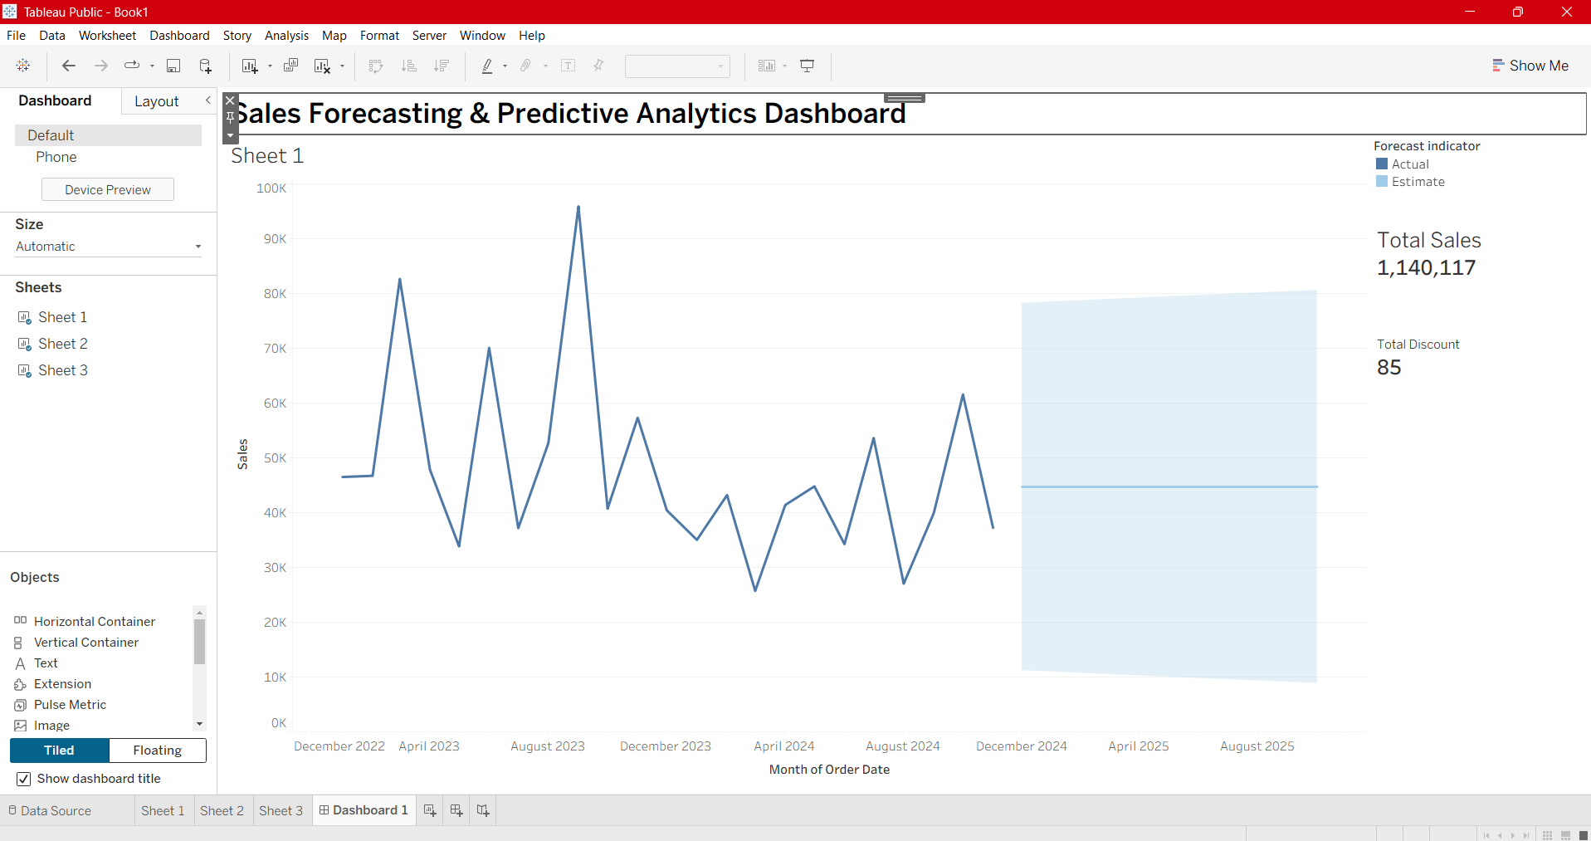
  - Power BI: Publish report to Power BI Service and share with stakeholders.
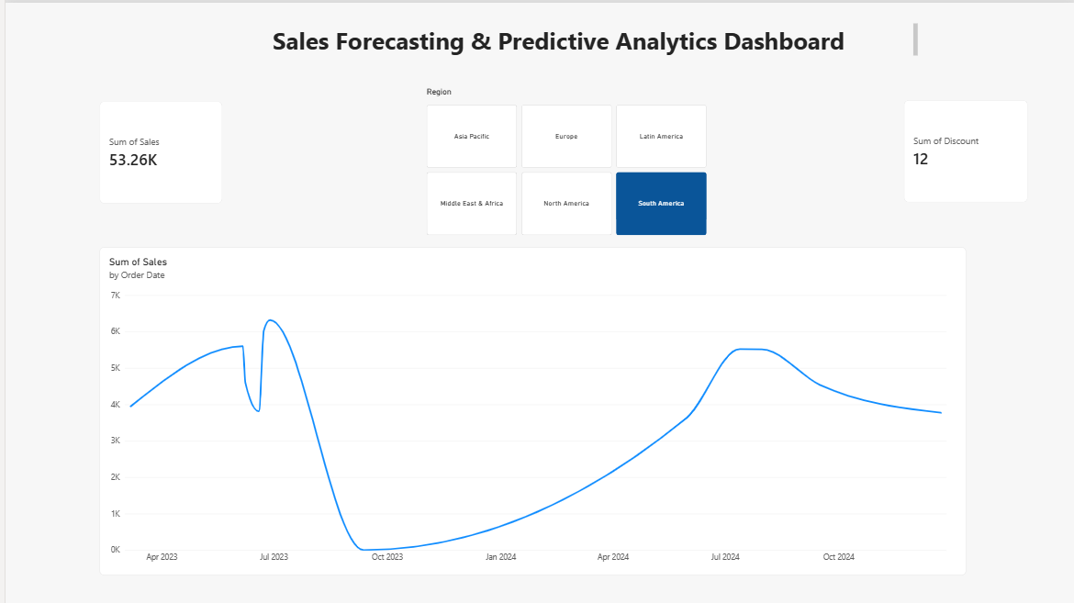
Experiment Datasets:
  - Dataset 1: Historical Sales Data (CSV) → Order ID, Order Date, Region, Sales
  - Dataset 2: Promotions Data (Excel) → Promotion ID, Region, Promotion Start/End Date, Discount

POST-LAB QUESTIONS :
- How did forecasting help in predicting future sales trends for business planning?
Forecasting converted raw historical sales records into actionable future projections, revealing upcoming growth trajectories and seasonal peak periods. This allowed for better operational alignment, enabling management to optimize inventory levels, allocate marketing budgets effectively, and set realistic regional sales quotas. By quantifying expected variance, the business could prepare for potential revenue dips well in advance rather than reacting after the fact.
- What forecasting method did you use, and why was it suitable for the dataset?
Exponential Smoothing (Tableau's default time series engine) was selected because retail sales data exhibits natural trend shifts and recurring seasonal cycles. This model effectively balances recent sales performance against historical patterns by weighting newer observations more heavily. It produced robust prediction intervals alongside baseline forecasts, making it well-suited for capturing retail demand spikes linked to promotional windows.
- What challenges, if any, did you face regarding missing data or irregular time intervals?
The main challenge involved gaps on non-transactional dates and irregular start/end ranges in the promotions dataset. Joining sparse promotion schedules with continuous sales dates created unaligned time slots and missing values. This required pre-processing to pad missing dates, forward-fill missing values, and aggregate sales to a uniform weekly grain before running the predictive model.
- How can predictive analytics influence decision-making in a retail environment?
Predictive analytics enables proactive supply chain and inventory management by ensuring high-demand items are restocked prior to forecasted surges, minimizing stockouts. It helps marketers evaluate expected promotional uplift, allowing them to discount items strategically rather than arbitrarily. Additionally, it optimizes workforce scheduling and store operations around predicted high-volume sales days, maximizing profitability

- What additional data (e.g., competitor pricing, economic indicators) could be integrated to improve forecast accuracy?
Integrating external economic indicators like consumer price index (CPI), inflation rates, and localized employment data would capture shifts in overall purchasing power. Competitor pricing, local event schedules, and real-time weather data could also account for sudden demand fluctuations that historical sales alone cannot explain. Adding customer demographic profiles would further refine region-specific target projections.

RESULT:
The historical sales and promotions datasets were successfully cleaned, integrated, and modeled in Tableau and Power BI. Forecasting techniques provided predicted sales trends, growth percentages, and region-wise performance expectations. The resulting dashboards allowed managers to visualize actual vs. forecasted sales, enabling better planning and datadriven decision-making.

ASSESSMENT

Description |  | Max Marks | Marks Awarded
Pre Lab Exercise |  | 5
In Lab Exercise |  | 10
Post Lab Exercise |  | 5
Viva |  | 10
 | Total | 30
 | Faculty Signature

